Task 2 - Test Log – Boundary & Edge Testing.
# | Description of test | Test data to be used (if required) | Expected outcome | Actual outcome | Comments and intended actions
- . | Start program | Run program | Please Enter your name:  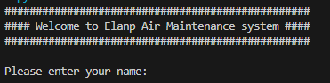 | Syntax Error  File "u:\2025-2026\Level 3 T-Level Digital Production, Design & Development\Teachers\Brankica\Employer Set Project (ESP)\Scenarios\Enlap Air\Task 2\main.py", line 52  def check_serial_num()  ^  SyntaxError: expected ':' | FAILED – This was corrected by adding a “:” to ensure the function is properly defined
 | Retest Start Program | Run Program | Please Enter your name:   | Please Enter your name:   | PASSED
 | Entering Name (invalid data) | 1 | Do not enter a number  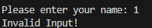 | Please enter the plane reference number:  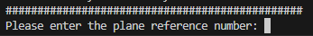 | FAILED – This was fixed by adding a try expect block in order to ensure the user does not enter numbers.
3 | RETEST Entering Name (invalid data) | 1 | Do not enter a number   | Do not enter a number   | PASSED
 | Entering Name (valid data) | Ryan | Please enter plane reference number   | Please enter plane reference number   | PASSED
 | Enter Serial Number (invalid) | 1 | Error should be 12 long  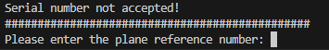 | Serial Number Accepted  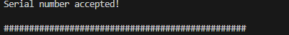 | FAILED – This was corrected by changing the if condition so the serial number is flagged as invalid if it is not 12 characters long.
5 | RETEST Enter serial number (invalid) | 1 | Error – Should be 12 long   | Error – Should be 12 long   | PASSED
 | Enter Serial Number (invalid Edge case)) | 12345678910 | Error should be 12 long   | Serial number accepted!   | FAILED – This was fixed by adding a check to the if condition using the bult in len() function to reject the serial number if not equal to 12
6 | RETEST Enter Serial Number (invalid Edge case)) | 12345678910 | Error should be 12 long   | Error should be 12 long   | PASSED
 | Enter Serial Number | ABC123456789 | Serial number accepted!   | Serial number accepted!   | PASSED
 | Test menu range (invalid Case) | 0 | Error – Out of range | Error – Out of range | PASSED
 | Test menu range (Extreme Case) | 1 | Please enter date of the previous maintenance job (DD/MM/YYYY): | Sorry did not chose an option within given range | FAILED – This was corrected by changing the range check to the correct values.
9 | RETEST Test menu range (Extreme Case) | 1 | Please enter date of the previous maintenance job (DD/MM/YYYY): | Please enter date of the previous maintenance job (DD/MM/YYYY): | PASSED
 | Test menu range (invalid Case) | A | Sorry, you did not enter a valid option number  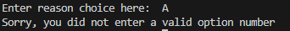 | Sorry, you did not enter a valid option number   | PASSED
12 | RETEST Test menu range (Edge Case – Lower End) | 1 | Please enter date of the previous maintenance job (DD/MM/YYYY): | Traceback (most recent call last):  File "u:\2025-2026\Level 3 T-Level Digital Production, Design & Development\Teachers\Brankica\Employer Set Project (ESP)\Scenarios\Enlap Air\Task 2\main.py", line 208, in <module>  job = get_job_date()  ^^^^^^^^^^^^^^  File "u:\2025-2026\Level 3 T-Level Digital Production, Design & Development\Teachers\Brankica\Employer Set Project (ESP)\Scenarios\Enlap Air\Task 2\main.py", line 14, in get_job_date  return job_dat  ^^^^^^^  NameError: name 'job_dat' is not defined. Did you mean: 'job_date'?  PS U:\2025-2026\Level 3 T-Level Digital Production, Design & Development\Teachers\Brankica\Employer Set Project (ESP)\Scenarios\Enlap Air\Task 2>  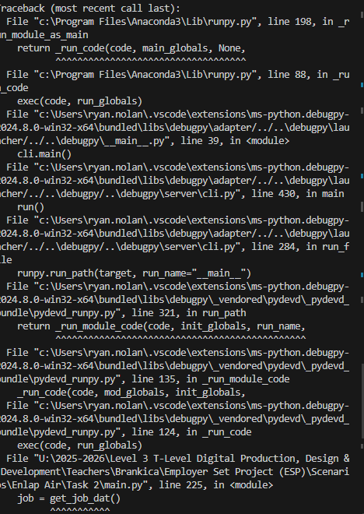 | FAILED – The problem was a spelling error, the code was returning job_dat when it should be job_date
12 | RETest menu range (Edge Case – Lower End ) | 1 | Please enter date of the previous maintenance job (DD/MM/YYYY): | Please enter date of the previous maintenance job (DD/MM/YYYY): | PASSED
 | Test menu range | 2 | Please enter date of the previous maintenance job (DD/MM/YYYY): | Please enter date of the previous maintenance job (DD/MM/YYYY): | PASSED
 | Test menu range | 3 | Please enter date of the previous maintenance job (DD/MM/YYYY): | Please enter date of the previous maintenance job (DD/MM/YYYY): | PASSED
 | Test menu range | 4 | Please enter date of the previous maintenance job (DD/MM/YYYY): | Please enter date of the previous maintenance job (DD/MM/YYYY): | PASSED
 | Test menu (Edge Case – Upper End) | 5 | Please enter date of the previous maintenance job (DD/MM/YYYY): | Please enter date of the previous maintenance job (DD/MM/YYYY): | PASSED
 | Test menu (Erroneous Case – Upper End) | 6 | “Error – Out of range “  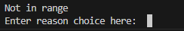 | job_reason = record_job_reason()  ^^^^^^^^^^^^^^^^^^^  File "u:\2025-2026\Level 3 T-Level Digital Production, Design & Development\Teachers\Brankica\Employer Set Project (ESP)\Scenarios\Enlap Air\Task 2\main.py", line 99, in record_job_reason  job_reason = reason_list[local_choice]  ~~~~~~~~~~~^^^^^^^^^^^^^^  IndexError: tuple index out of range  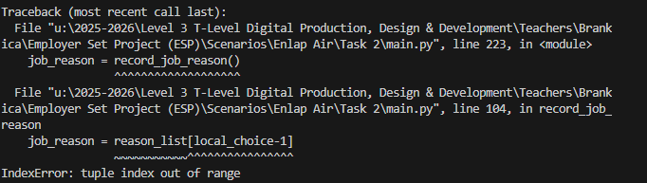 | FAILED - The problem was with array indexing, this has now been fixed by fetching the correct value index from the array
 | Test menu (Erroneous Case – Upper End) | 6 | Error – Out of range   | “Error – Out of range”   | PASSED
 | Please enter date of the previous maintenance job (DD/MM/YYYY): | 12/07/2029 | Error – In the future | Please enter the number of hours spent on the job to the nearest 1/4 hour as a decimal  e.g 1 hour 15 minutes = 1.25  Enter time spent here: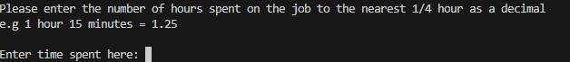 | FAILED – This was corrected by implementing the use of the datetime module and comparing date of today with users input, rejecting future dates
17 | RETEST Please enter date of the previous maintenance job (DD/MM/YYYY): | 12/07/2029 | Error – In the future | Date cannot be in the future | PASSED
17 | RETEST Please enter date of the previous maintenance job (DD/MM/YYYY): | 21/11/2024 | Please enter the number of hours spent on the job to the nearest 1/4 hour as a decimal  e.g 1 hour 15 minutes = 1.25   | ###############################################  Please enter the number of hours spent on the job to the nearest 1/4 hour as a decimal  e.g 1 hour 15 minutes = 1.25  Enter time spent here:   | PASSED
 | enter the number of hours spent on the job to the nearest 1/4 hour as a decimal  e.g 1 hour 15 minutes = 1.25 | a | Sorry, you did not enter a time in a valid format | Sorry, you did not enter a time in a valid format | PASSED
 | Enter Number of hours spent on job | 2.75 | Time value accepted!  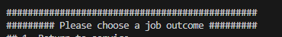 | Time value accepted!   | PASSED
 | Enter Number of hours spent on job (Invalid Data) | 0.2 | Sorry, you did not enter a time in a valid format | Time value accepted!   | FAILED – This was corrected by implementing the use of an if condition checking if the input was divisible by 0.25
20 | RETEST Enter Number of hours spent on job |  | Sorry, you did not enter a time in a valid format | Sorry, you did not enter a time in a valid format | PASSED
 | Test Report generation | 1 | Print Summary  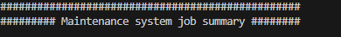 | Traceback (most recent call last):  File "u:\2025-2026\Level 3 T-Level Digital Production, Design & Development\Teachers\Brankica\Employer Set Project (ESP)\Scenarios\Enlap Air\Task 2\main.py", line 218, in <module>  next_service = next_service_date()  ^^^^^^^^^^^^^^^^^^^  File "u:\2025-2026\Level 3 T-Level Digital Production, Design & Development\Teachers\Brankica\Employer Set Project (ESP)\Scenarios\Enlap Air\Task 2\main.py", line 39, in next_service_date  next_date = str(job_day) + "/" + str(job_month) + "/" + int(temp_year)  ~~~~~~~~~~~~~~~~~~~~~~~~~~~~~~~~~~~~~~~~~~^~~~~~~~~~~~~~~~  TypeError: can only concatenate str (not "int") to str  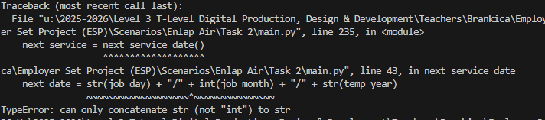 | FAILED – This has been corrected by changing the statement to cast temp_year to a string instead of as an integer
21 | Retest Test Report generation | 1 | Print Maintenance Report  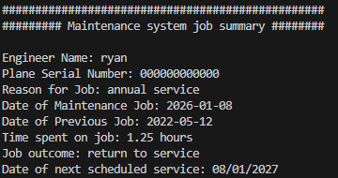 | #################################################  ######### Maintenance system job summary ########  Engineer Name: ryan  Plane Serial Number: 000000000000  Reason for Job: annual service  Date of Maintenance Job: 2026-01-08  Date of Previous Job: 2022-05-12  Time spent on job: 1.25 hours  Job outcome: return to service  Date of next scheduled service: 08/01/2027   | PASSED
 | Test 30 day warning | 2 | #############  WARNING!!!!!  #############  This plane has had more than one maintenance job in less than 30 days  The plane must undergo a safety investigation  Job outcome has been set to: grounded - do not fly  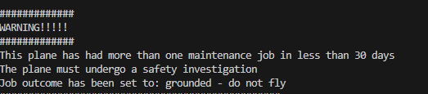 | #################################################  ######### Maintenance system job summary ########  Engineer Name: ryan  Plane Serial Number: 000000000000  Reason for Job: annual service  Date of Maintenance Job: 2026-01-08  Date of Previous Job: 2022-05-12  Time spent on job: 1.25 hours  Job outcome: return to service  Date of next scheduled service: 08/01/2027   | FAILED – The system did not ground the flight as multiple maintance have occurred within 30 days, this was fixed by adding error handling to catch a type mismatch error
22 | RETEST 30 day warning |  | WARNING!!!!!  #############  This plane has had more than one maintenance job in less than 30 days  The plane must undergo a safety investigation  Job outcome has been set to: grounded - do not fly   | #############  WARNING!!!!!  #############  This plane has had more than one maintenance job in less than 30 days  The plane must undergo a safety investigation  Job outcome has been set to: grounded - do not fly   | PASSED
 | Test menu range (Edge Case – Upper End) | 3 | #################################################  ######### Maintenance system job summary ########  Engineer Name: ryan  Plane Serial Number: 000000000000  Reason for Job: annual service  Date of Maintenance Job: 2026-01-08  Date of Previous Job: 2026-01-01  Time spent on job: 1.25 hours  Job outcome: grounded - do not fly  Date of next scheduled service: 08/01/2027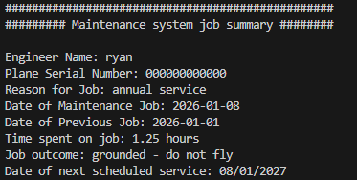 | #################################################  ######### Maintenance system job summary ########  Engineer Name: ryan  Plane Serial Number: 000000000000  Reason for Job: annual service  Date of Maintenance Job: 2026-01-08  Date of Previous Job: 2026-01-02  Time spent on job: 1.25 hours  Job outcome: grounded - do not fly  Date of next scheduled service: 08/01/2  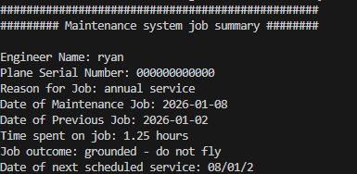 | FAILED – there is a logical error causing the date of next schedule to appear wrong, This was caused by a typo causing the wrong variable to be incremented by 1, this has now been changed to correct variable name .
23 | RETEST Correct Date of next schedule service | 12/05/2025 | Date of next scheduled service: 08/01/2027 | Date of next scheduled service: 08/01/2027 | PASSED
 | Write to file |  | Prints report to file | Engineer Name: ryanPlane Serial Number: 000000000000Reason for job: annual serviceDate of Maintenance Job: 2026-01-08Date of Previous Job: 2026-01-02Time spent on job: 1.25 hours  Job outcome: grounded - do not flyDate of next scheduled service: 08/01/2027 | PASSED

